**Final project:**

**Puslapio www.Svokosprendimai.lt**

Edita Karčiauskienė

**Software Developmet Academy**

**2020.07.01**

**Content**

**Document Purpose** 2

**Testing section** 3

**Testing checklist** 4

**Tase case** 7

**Bugs** 8

**Inprovements** 11

**Test Design Techniques** 13

**Document Purpose**

To test the functionality of the page "Švoko sprendimai" (www.svokosprendimai.lt).

Check on the part of the user whether the page has no bugs or is fully functional in all browsers. See if the structure is comfortable.

**Testing section**

**Testing checklist**

**Testing object:** [**http://www.svoksprendimai.lt/**](http://www.svoksprendimai.lt/)

|  |  |  |  |
| --- | --- | --- | --- |
| **Type** | **ID** | **Checkpoint** | **Yes/No** |
| General page | 1 | Check header: |  |
|  |  | Check if "Pradžia" page opens when a user clicks on a button "Pradžia" | Yes |
|  |  | Check if "Paslaugos" drop dwon opens when a user clicks on a menu "Paslaugos" | Yes |
|  |  | Check if "Kontaktai" page opens when a user clicks on a button "Kontaktai“ | Yes |
|  | 2 | Check carousel or perform its function | No |
|  | 3 | Check „Siūlome paslaugas“: |  |
|  |  | Check if "Vėdinimas" page opens when a user clicks on a button "Vėdinimas" | Yes |
|  |  | Check if "Šildymas" page opens when a user clicks on a button "Šildymas" | Yes |
|  |  | Check if "Oro kondicionavimas" page opens when a user clicks on a button "Oro kondicionavimas" | Yes |
|  |  | Check if "Šildymos siurbliai" page opens when a user clicks on a button "Šildymos siurbliai" | Yes |
|  | 4 | Check if "Užduokite klaausimą" page opens when a user clicks on a button "Užduokite klausimą" | Yes |
| 5 | Check for spelling errors | Yes |
| Vėdinimo sistemos montavimas |  | Open drop dwon list „Paslaugos“ end press „Vėdinimo sistemos montavimas“ |  |
| 1 | Check if "Vėdinimo sistemos montavimas" page opens when a user clicks on a button "Vėdinimo sistemos montavimas" | Yes |
|  | 2 | Check if "Šildymo sistemos montavimas" page opens when a user clicks on a button "Šildymo sistemos montavimas" | Yes |
|  | 3 | Check if "Oro kondicionavimo sistemos montavimas" page opens when a user clicks on a button "Oro kondicionavimo sistemos montavimas" | Yes |
|  | 4 | Check if "Šilumos siurbliai oras/vanduo, gruntas/vanduo" page opens when a user clicks on a button "Šilumos siurbliai oras/vanduo, gruntas/vanduo" | Yes |
|  | 5 | Check if "Kontaktai" page opens when a user clicks on a button "Kontaktai" | Yes |
|  | 6 | Check for spelling errors | NO |
| Šilumos sistemos įrengima |  | Open drop dwon list „Paslaugos“ end press „Šilumos sistemos įrengimas“ |  |
| 1 | Check if "Vėdinimo sistemos montavimas" page opens when a user clicks on a button "Vėdinimo sistemos montavimas" | Yes |
|  | 2 | Check if "Šildymo sistemos montavimas" page opens when a user clicks on a button "Šildymo sistemos montavimas" | Yes |
|  | 3 | Check if "Oro kondicionavimo sistemos montavimas" page opens when a user clicks on a button "Oro kondicionavimo sistemos montavimas" | Yes |
|  | 4 | Check if "Šilumos siurbliai oras/vanduo, gruntas/vanduo" page opens when a user clicks on a button "Šilumos siurbliai oras/vanduo, gruntas/vanduo" | Yes |
|  | 5 | Check if "Kontaktai" page opens when a user clicks on a button "Kontaktai" | Yes |
|  | 6 | Check for spelling errors | Yes |
| Oro kondicionavimo sistemos įrengimas |  | Open drop dwon list „Paslaugos“ end press „Oro kondicionavimo sistemos montavimas“ |  |
| 1 | Check if "Vėdinimo sistemos montavimas" page opens when a user clicks on a button "Vėdinimo sistemos montavimas" | Yes |
|  | 2 | Check if "Šildymo sistemos montavimas" page opens when a user clicks on a button "Šildymo sistemos montavimas" | Yes |
|  | 3 | Check if "Oro kondicionavimo sistemos montavimas" page opens when a user clicks on a button "Oro kondicionavimo sistemos montavimas" | Yes |
|  | 4 | Check if "Šilumos siurbliai oras/vanduo, gruntas/vanduo" page opens when a user clicks on a button "Šilumos siurbliai oras/vanduo, gruntas/vanduo" | Yes |
|  | 5 | Check if "Kontaktai" page opens when a user clicks on a button "Kontaktai" | Yes |
|  | 6 | Check for spelling errors | Yes |
| Šilumos siurbliai oras/vanduo, gruntas/vanduo |  | Open drop dwon list „Paslaugos“ end press „Šilumos siurbliai oras/vanduo, gruntas/oras“ |  |
| 1 | Check if "Vėdinimo sistemos montavimas" page opens when a user clicks on a button "Vėdinimo sistemos montavimas" | Yes |
|  | 2 | Check if "Šildymo sistemos montavimas" page opens when a user clicks on a button "Šildymo sistemos montavimas" | Yes |
|  | 3 | Check if "Oro kondicionavimo sistemos montavimas" page opens when a user clicks on a button "Oro kondicionavimo sistemos montavimas" | Yes |
|  | 4 | Check if "Šilumos siurbliai oras/vanduo, gruntas/vanduo" page opens when a user clicks on a button "Šilumos siurbliai oras/vanduo, gruntas/vanduo" | Yes |
|  | 5 | Check if "Kontaktai" page opens when a user clicks on a button "Kontaktai" | Yes |
|  | 6 | Check for spelling errors | NO |
| Kontaktai | 1 | Check „Jūsų vardas field: |  |
|  |  | Check can enter any characters in the field | No |
|  |  | Check the maximum number of characters that can be entered | No |
|  | 2 | Check „El-paštas“ field: |  |
|  |  | Check can enter any characters in the field | No |
|  |  | Check the maximum number of characters that can be entered | No |
|  | 3 | Check „Tema“ field: |  |
|  |  | Check can enter any characters in the field | Yes |
|  |  | Check the maximum number of characters that can be entered | No |
|  | 4 | Check if you can send without entering anything | Yes |
|  | 5 | Check that only the name can be sent | Yes |
|  | 6 | Check that after entering the name and E-mail can be sent | Yes |
|  | 7 | Check that after entering the name, E-mail and subject can be sent | Yes |
|  | 8 | Check that after entering the name, E-mail, subject and massenger can be sent | Yes |
| Browsers |  | check if the page works well in all browsers | No |
|  |  |  |  |

# **Tase case**



# **Bugs**

General list of bugs

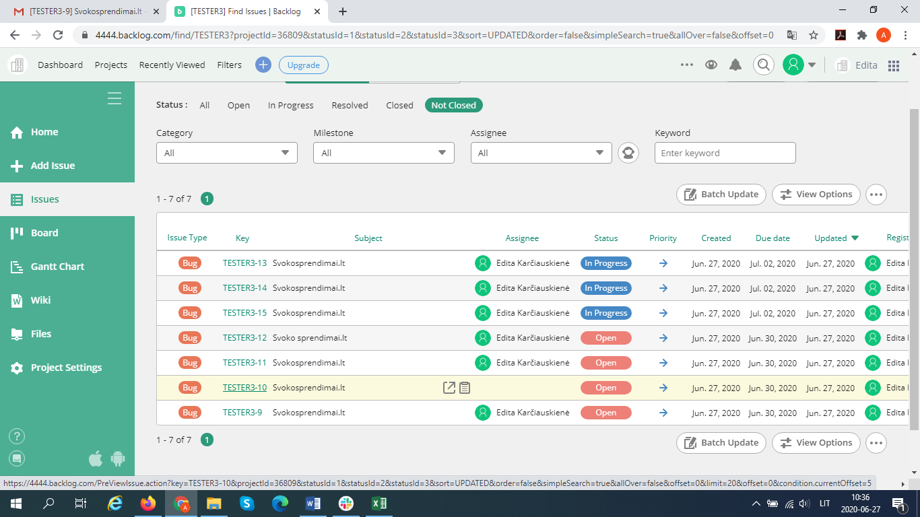

When you open the page, the following image is displayed on your phone.

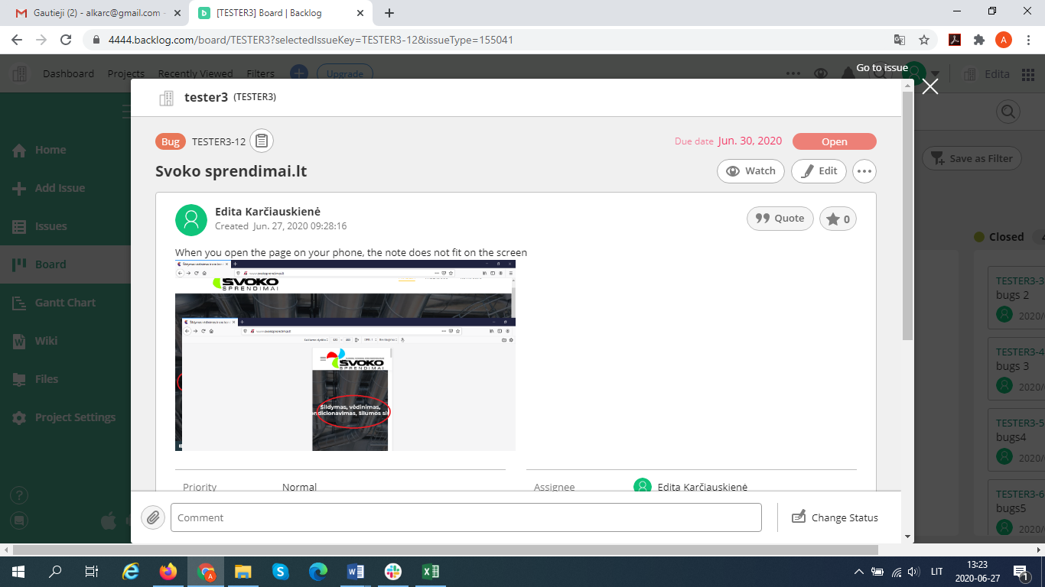

When you open the page in Tablet, you see the following image.

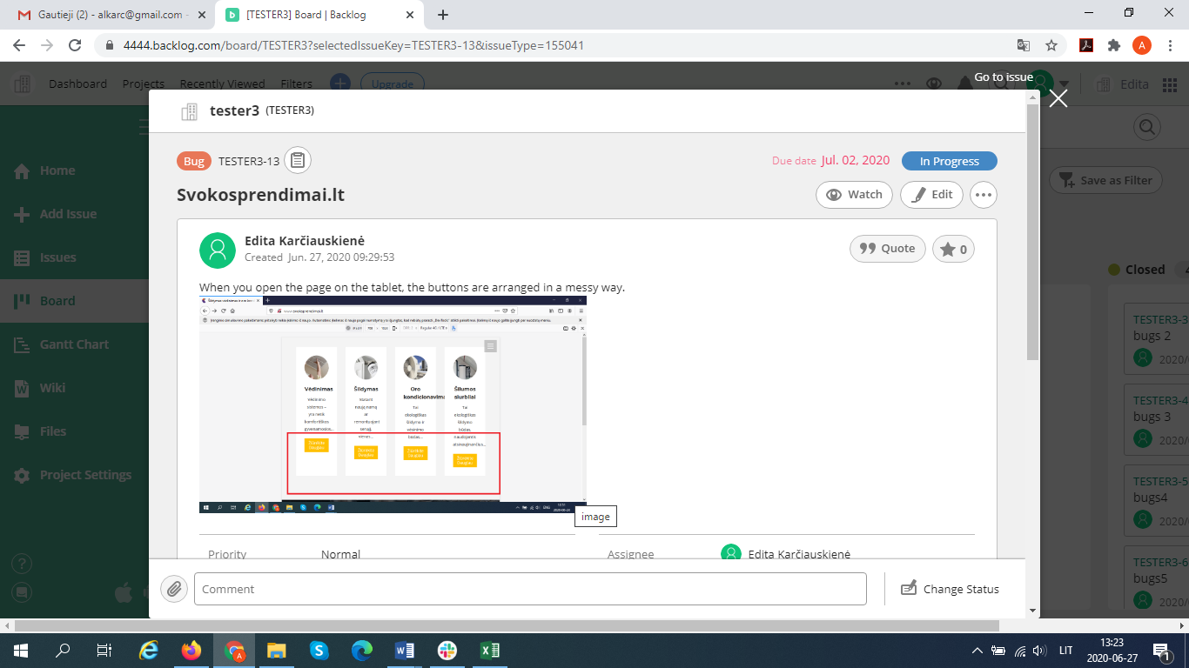

“Užduokite klausimą” in the questionnaire there is no character validation.

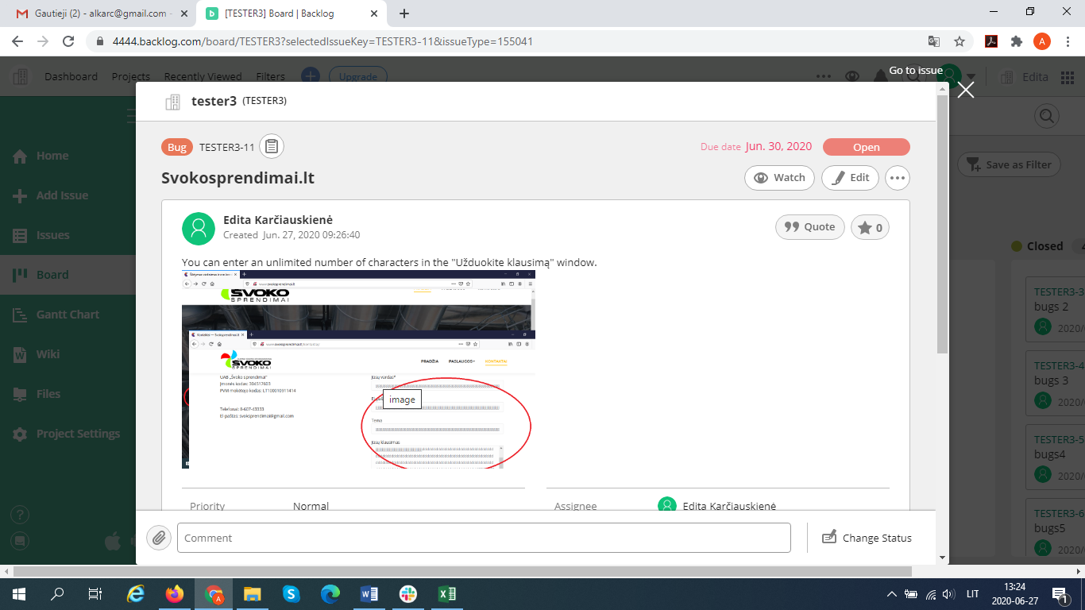

The carousel does not work.

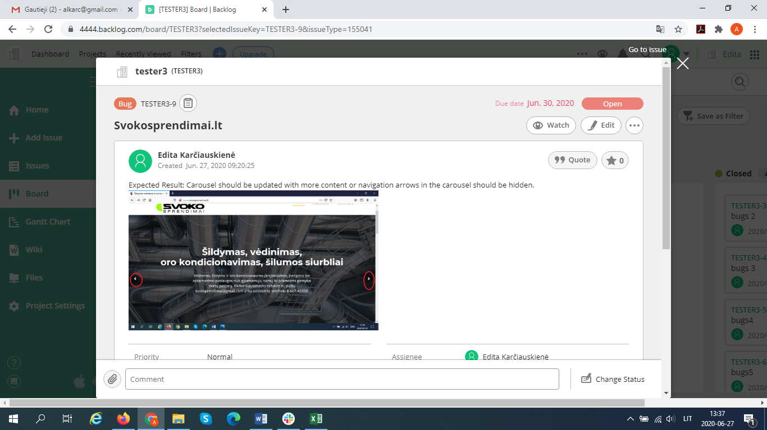

**Inprovements**

Home page to remove the carousel, because I do not think it is necessary in this case.

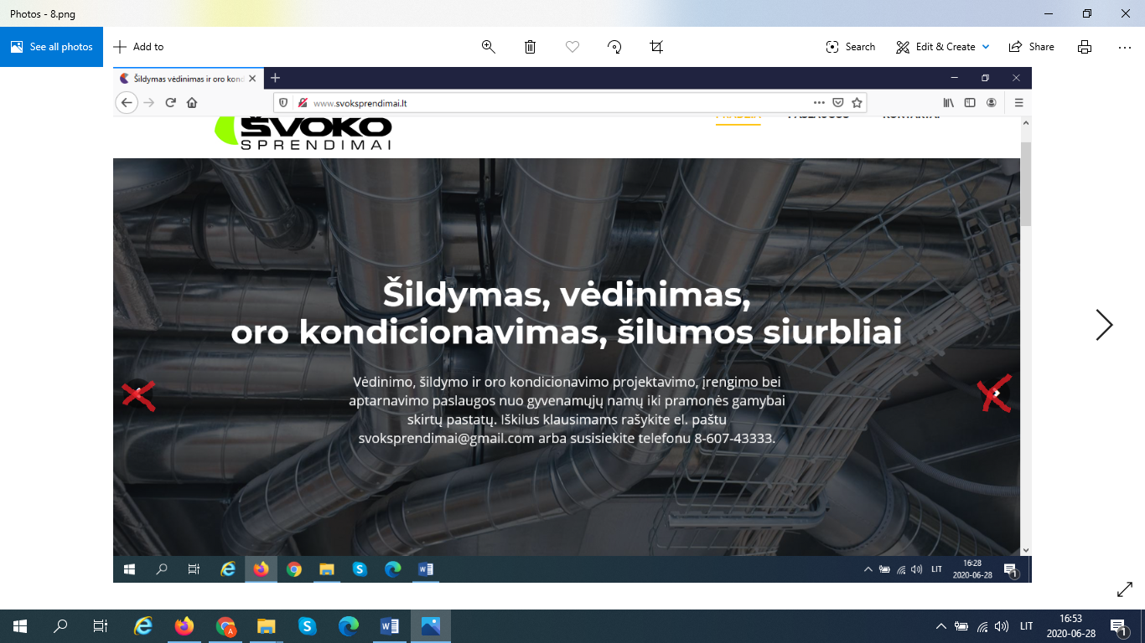

On the contact page, in the "Užduokite klausimą" section, in the "Jūsų vardas" field of the form I could write what the character validation is and when entering characters that do not match the name characters (@ # $ %% ^^ &) a message should pop up warning that such characters cannot be entered (The name entered is invalid).  
 I think that an asterix should be placed in the "Jūsų klausimas" section of the form, because sending only your name and address without a message does not make sense.

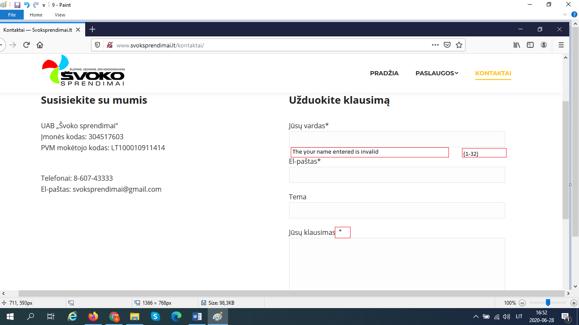

# 

# **Test Design Techniques**

Since the page is not large and covers very few areas, I have not used many testing methods.

I used it during this project:

* Black-box testing
* Which includes error gessing
* Exploratory testing

**Reflection**

To be frank, this job was a real challenge as I don’t speak English very well. The work was a good practice to remember the use of Word and Excel, which is very commendable. The hardest part of this job was writing a test case, as for me it is an area that requires more practice. But I am very grateful to the teachers for their patience, help and kindness.